A

Mini Project Report

On

“Placement Prediction Application”

Submitted to

CHHATTISGARH SWAMI VIVEKANAND TECHNICAL UNIVERSITY
BHILAI

in partial fulfillment of the requirement of for the award of degree

Of

Bachelors of Technology

In
COMPUTER SCIENCE AND ENGINEERING
By
UZAIR AHMED

DEPARTMENT OF COMPUTER SCIENCE AND ENGINEERING
SHRI SHANKARACHARYA TECHNICAL CAMPUS,
JUNWANI, BHILAI(C.G.)

SESSION 2021-2022

CERTIFICATE

This is to certify that the thesis report of the project submitted is an outcome of the project entitled “Placement Prediction Application” carried out by Uzair Ahmed bearing Roll no. 30140222131 carried out under my guidance and supervision for the award of Degree in B.Tech in Computer Science and Engineering of Chhattisgarh Swami Vivekanand Technical university, Bhilai(C.G.),India.
To the best of my knowledge the report.

(1)Embodies the work of the candidates themself.
(2)Fulfills the requirements of the ordinance relating to the B.Tech Degree of the University.And ,
(3)Is up to the desired standard for the purpose of which is submitted.

(Signature of the Class Teacher)
DR. ABHA CHOUBEY

Computer Science & Egineering Department
Shri ShankaraCharya Technical Campus
Junwani,Bhilai(C.G.)

The project work as mentioned above is hereby being recommended and forwarded for examination and evaluation.

(Signature of Head of Department with seal)

ACKNOWLEDGEMENT

I wish to express my gratitude to all those who have been instrumental and associated with this project and also helped in its successful completion at the shri shankracharya technical campus,junwani. At the very outset , I convey my gratitude to DR. ABHA CHOUBEY for giving me time and help needed for completion of this project.
I would like to express my special gratitude and thanks to Department of Computer sciences of shri shankracharya technical campus,junwani for giving me time and help needed for completion of this project.
I would like to express my gratitude towards my parents for their encouragement which helped me in the completion of this project.

(Signature of student)

Abstract

This abstract presents a placement prediction application developed using R programming language, ggplot for visualization, caret for machine learning, and shiny for user interface (UI) development. The application aims to assist in predicting the placement of individuals in various domains based on relevant features.

The application leverages the capabilities of R programming to handle data preprocessing, exploratory data analysis, and predictive modeling. The ggplot package is utilized for creating interactive and visually appealing data visualizations, aiding in the identification of patterns and insights within the dataset.

Caret, a powerful R package, is employed for implementing machine learning algorithms. It provides a unified framework for training and evaluating models, automating tasks such as cross-validation, hyperparameter tuning, and feature selection. By utilizing caret, the application can efficiently develop and compare multiple predictive models.

To enhance the user experience, the shiny package is utilized to create a user-friendly and interactive UI. The shiny framework enables the development of web-based applications, allowing users to input their data, customize model parameters, and view prediction results in real-time.

By combining the strengths of R programming, ggplot, caret, and shiny, this placement prediction application offers a comprehensive solution for users to explore and predict placement outcomes.

INTRODUCTION

Placement Prediction Application

Introduction:

Placement prediction is a critical task in various domains, such as education, recruitment, and career counseling. The ability to accurately predict the placement outcome for individuals can greatly assist decision-making processes and optimize resource allocation. In this context, the combination of R programming, ggplot for visualization, caret for machine learning, and shiny for user interface (UI) development offers a powerful solution for creating a placement prediction application.

R programming, known for its extensive collection of statistical and machine learning libraries, provides a versatile environment for handling data manipulation, exploratory data analysis, and predictive modeling. Its flexibility allows developers to implement complex algorithms and techniques required for accurate placement prediction.

Visualization plays a crucial role in understanding patterns and relationships within the dataset. The ggplot package, a popular data visualization library in R, empowers users to create visually appealing and interactive plots. By leveraging ggplot, the placement prediction application can present data in a comprehensible manner, helping users identify meaningful insights and make informed decisions.

Caret, a comprehensive R package, acts as a unified framework for machine learning tasks. It simplifies the process of model training, evaluation, and comparison by providing a consistent interface for various algorithms. With caret, developers can automate essential tasks such as cross-validation, hyperparameter tuning, and feature selection, ensuring optimal model performance for placement prediction.

A user-friendly and intuitive interface is crucial for the successful deployment and adoption of any application. Shiny, an R package for building web applications, allows developers to create interactive UIs effortlessly. By utilizing shiny, the placement prediction application can offer a seamless user experience, enabling users to input their data, customize model parameters, and obtain real-time predictions.

In summary, the integration of R programming, ggplot, caret, and shiny offers a robust solution for developing a placement prediction application. This combination of tools enables efficient data processing, advanced visualization, accurate machine learning modeling, and a user-friendly interface. By leveraging these technologies, the application empowers users to gain valuable insights and make informed decisions regarding placement outcomes, ultimately enhancing the efficiency and effectiveness of placement processes in various domains.

Technologies used in this projects are as follows-
R language
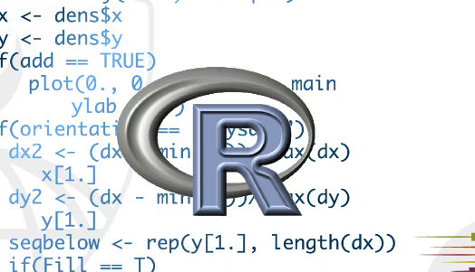
R is a language and environment for statistical computing and graphics. It is a GNU project which is similar to the S language and environment which was developed at Bell Laboratories (formerly AT&T, now Lucent Technologies) by John Chambers and colleagues.
Caret Library
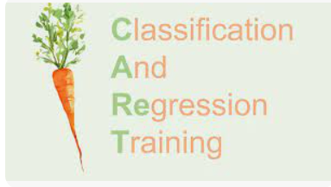
The caret package (short for Classification And REgression Training) contains functions to streamline the model training process for complex regression and classification problems. The package utilizes a number of R packages but tries not to load them all at package start-up (by removing formal package dependencies, the package startup time can be greatly decreased).

GGPLOT
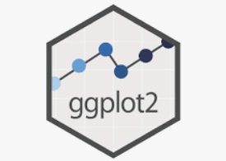
ggplot2 is a system for declaratively creating graphics, based on The Grammar of Graphics. You provide the data, tell ggplot2 how to map variables to aesthetics, what graphical primitives to use, and it takes care of the details.

Shiny UI

Shiny is an open source R package that provides an elegant and powerful web framework for building web applications using R. Shiny helps you turn your analyses into interactive web applications without requiring HTML, CSS, or JavaScript knowledge. Learn Shiny.
Working With Project

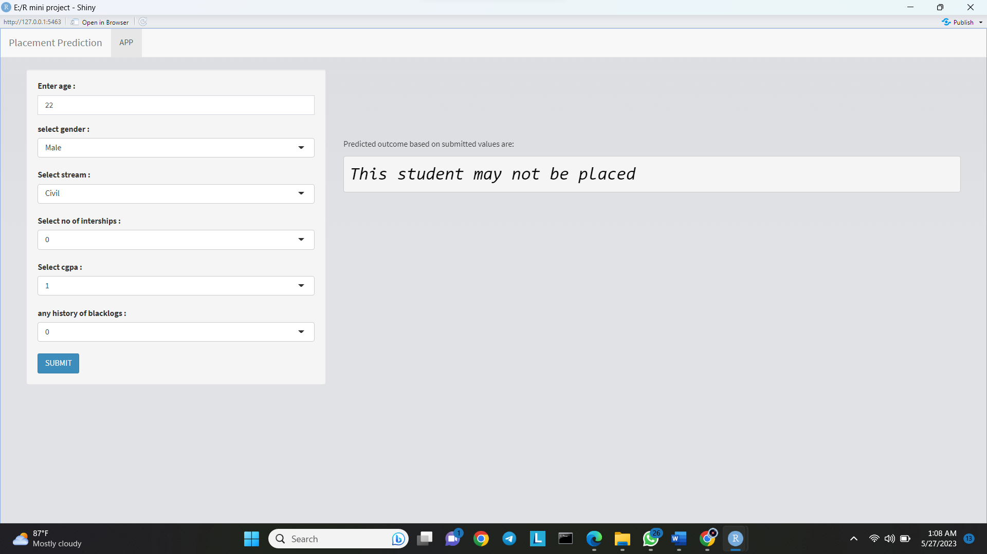
- Start by filling up the following form. It has all the fields as necessary.
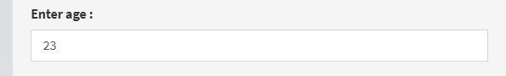
- Enter age in Interger Format.
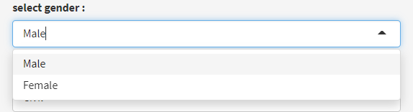
- Select Gender from drop down menu.

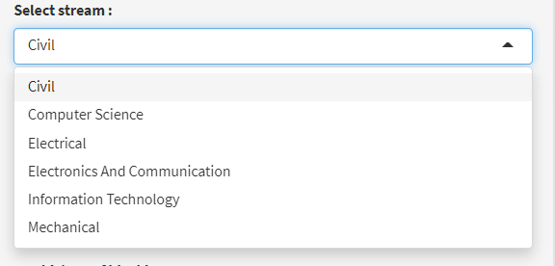
- Select your branch from the drop down menu.
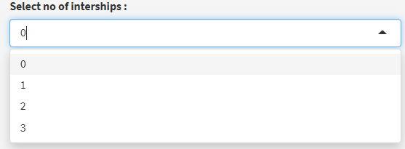
- Select the number of internships you have done till date. If no internships are done then this field is to be kept to its default value.
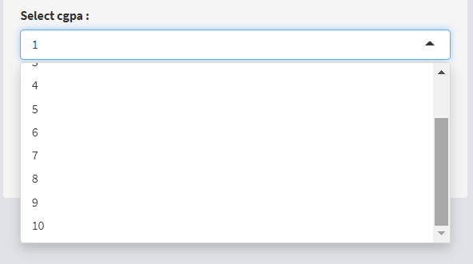
- Select your CGPA from the drop down menu. or aggregate.

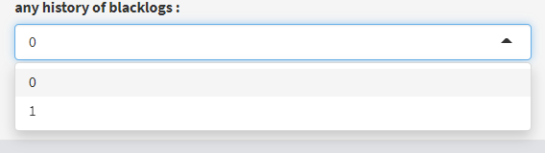
- If any history of backlog then select one. Else leave to default or 0.
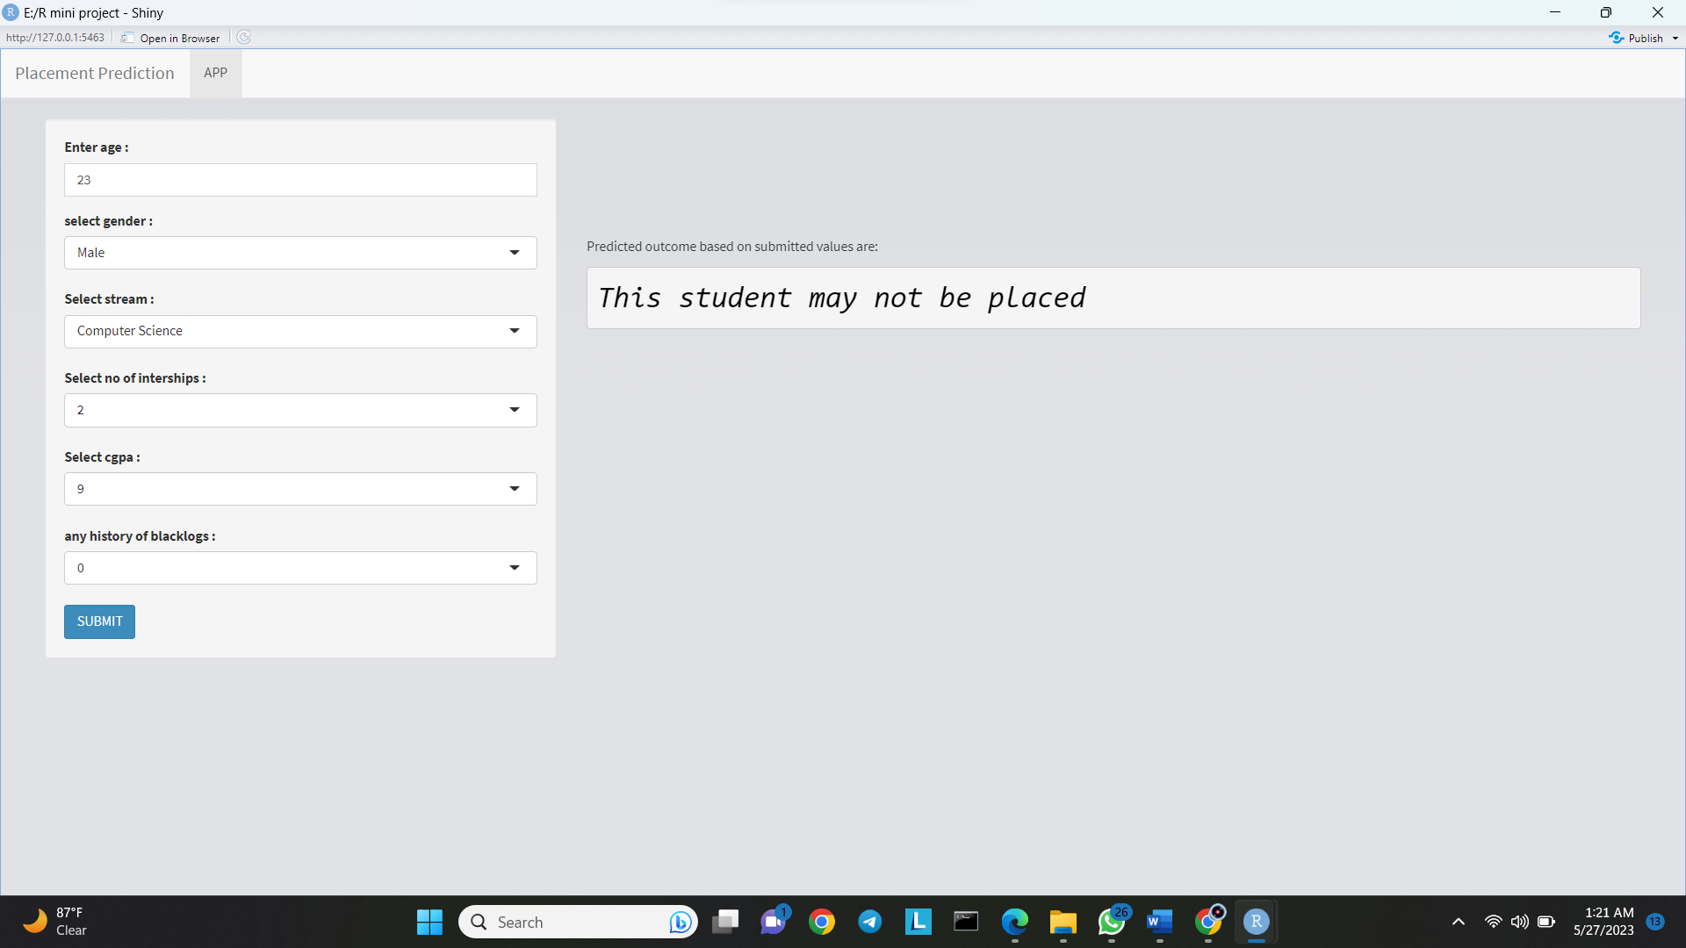
- Cross check and verify your details before submitting the value. Above is an example of a filled form.
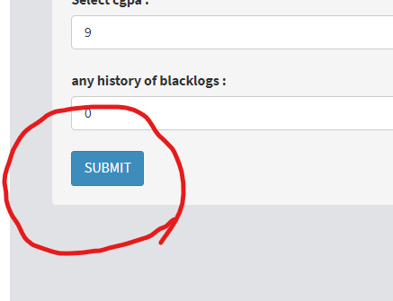
- Hit the submit button to check for the prediction based of the current input values.
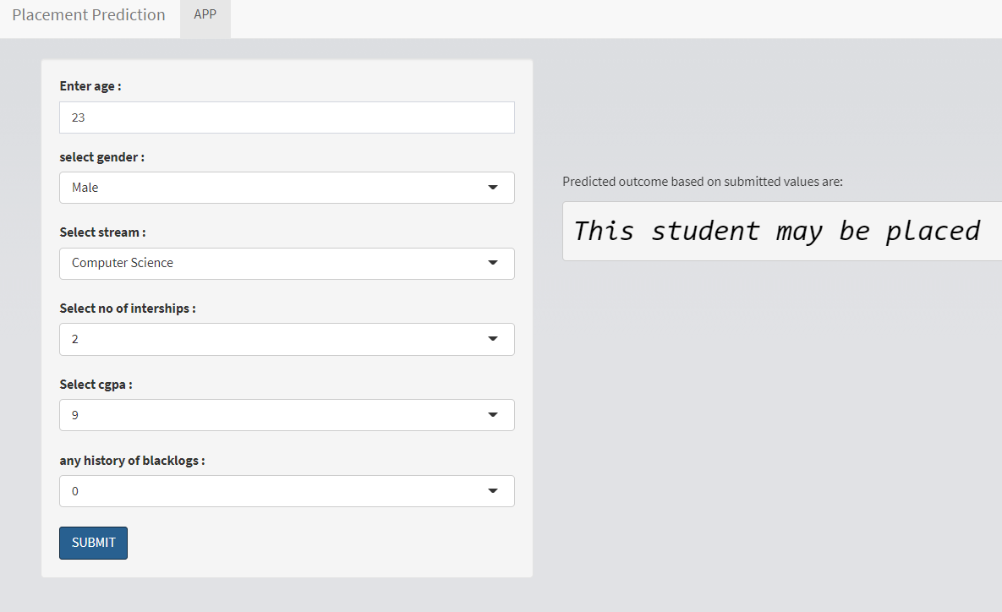
- The output is printed on the left handside of the form. In example case the output predicted is “May be placed”.

Reading the Training and Testing Dataset:

dataset <- read.csv(choose.files())

Changing all the variables of dataset to factors for better prediction:
dataset$Gender<-factor(dataset$Gender)
dataset$Stream<-factor(dataset$Stream)
dataset$Internships<-factor(dataset$Internships)
dataset$Hostel<-NULL
dataset$HistoryOfBacklogs<-factor(dataset$HistoryOfBacklogs)
dataset$PlacedOrNot<-factor(dataset$PlacedOrNot)

Checking the dimensions and Stastical Summary of the dataset:
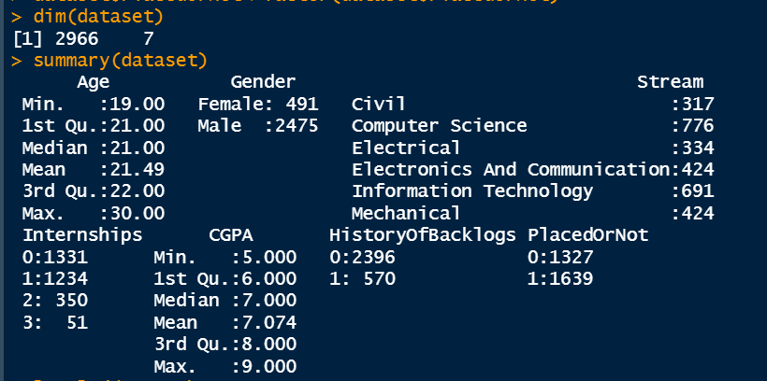

Creating Training and Validation dataset by partitioning the dataset:
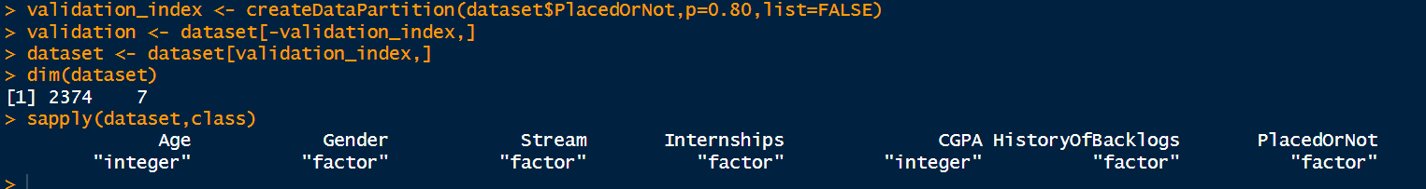
Checking the summary and first entries of the training dataset after partitioning:
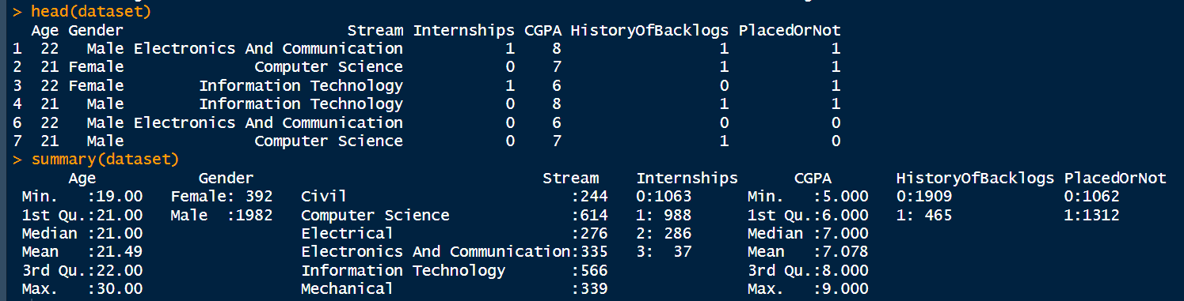
Plotting the dataset:
plot(x=dataset$PlacedOrNot,y=dataset$CGPA,type="o")
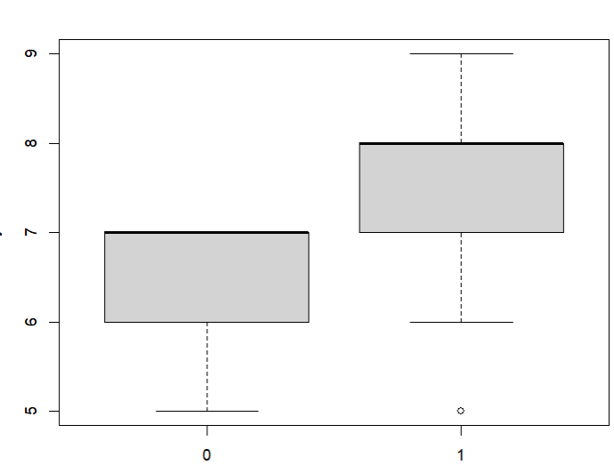
Training the model on the training dataset on various regression classification algorithms:
control <- trainControl(method="cv", number=10)
metric <- "Accuracy"
set.seed(7)
fit.lda <- train(PlacedOrNot~., data=dataset, method="lda", metric=metric, trControl=control)
# b) nonlinear algorithms
# CART
set.seed(7)
fit.cart <- train(PlacedOrNot~., data=dataset, method="rpart", metric=metric, trControl=control)
# kNN
set.seed(7)
fit.knn <- train(PlacedOrNot~., data=dataset, method="knn", metric=metric, trControl=control)
# c) advanced algorithms
# SVM
set.seed(7)
fit.svm <- train(PlacedOrNot~., data=dataset, method="svmRadial", metric=metric, trControl=control)
# Random Forest
set.seed(7)
fit.rf <- train(PlacedOrNot~., data=dataset, method="rf", metric=metric, trControl=control)
Checking models for performance:
> results <- resamples(list(lda=fit.lda, cart=fit.cart, knn=fit.knn, svm=fit.svm, rf=fit.rf))
> summary(results)

Call:
summary.resamples(object = results)

Models: lda, cart, knn, svm, rf
Number of resamples: 10

Accuracy
Min. 1st Qu. Median Mean 3rd Qu. Max. NA's
lda 0.7468354 0.7531513 0.7742616 0.7691841 0.7797708 0.7932489 0
cart 0.7899160 0.8291139 0.8357887 0.8311084 0.8401677 0.8523207 0
knn 0.8403361 0.8607595 0.8691983 0.8677446 0.8739496 0.8902954 0
svm 0.8109244 0.8450963 0.8589600 0.8559533 0.8691983 0.8781513 0
rf 0.8613445 0.8713080 0.8802521 0.8837500 0.8935752 0.9198312 0

Kappa
Min. 1st Qu. Median Mean 3rd Qu. Max. NA's
lda 0.4898106 0.5031370 0.5452698 0.5340569 0.5558110 0.5791934 0
cart 0.5862884 0.6635344 0.6762172 0.6666567 0.6847689 0.7047728 0
knn 0.6828225 0.7222605 0.7389848 0.7360498 0.7487110 0.7789179 0
svm 0.6252886 0.6927696 0.7178296 0.7127598 0.7387399 0.7577396 0
rf 0.7231973 0.7439889 0.7606135 0.7678583 0.7869888 0.8391613 0

> dotplot(results)
> print(fit.rf)
Random Forest

2374 samples
6 predictor
2 classes: '0', '1'

No pre-processing
Resampling: Cross-Validated (10 fold)
Summary of sample sizes: 2137, 2137, 2136, 2137, 2136, 2137, ...
Resampling results across tuning parameters:

mtry Accuracy Kappa
2 0.8706946 0.7420361
7 0.8837500 0.7678583
12 0.8774279 0.7548667

Accuracy was used to select the optimal model using the largest value.
The final value used for the model was mtry = 7.

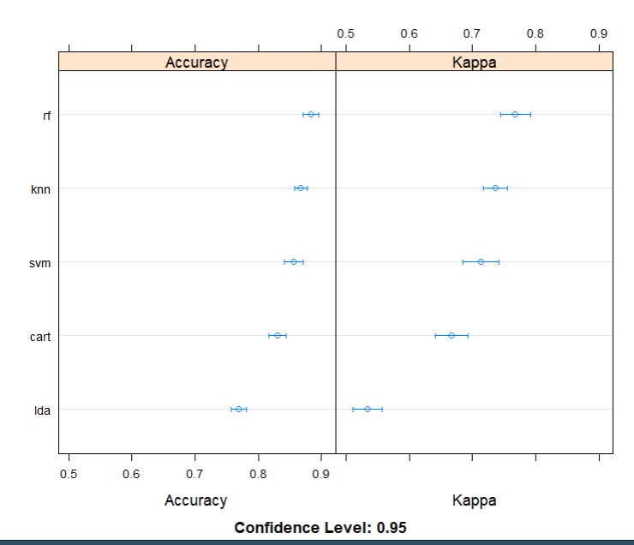

Validating the model:
> # estimate skill of LDA on the validation dataset
> predictions <- predict(fit.rf, validation)
> confusionMatrix(predictions, validation$PlacedOrNot)
Confusion Matrix and Statistics

Reference
Prediction 0 1
0 250 57
1 15 270

Accuracy : 0.8784
95% CI : (0.8493, 0.9036)
No Information Rate : 0.5524
P-Value [Acc > NIR] : < 2.2e-16

Kappa : 0.7577

Mcnemar's Test P-Value : 1.352e-06

Sensitivity : 0.9434
Specificity : 0.8257
Pos Pred Value : 0.8143
Neg Pred Value : 0.9474
Prevalence : 0.4476
Detection Rate : 0.4223
Detection Prevalence : 0.5186
Balanced Accuracy : 0.8845

'Positive' Class : 0

Frontend Code of the Application:
library(shiny)
library(shinyWidgets)
library(shinydashboard)

backgroundImageCSS <- " /*background-color: #cccccc;*/
height: 91vh;
background-position: center;
background-repeat: no-repeat;
/* background-size: cover;*/
background-image: url('%s');
"

ui <- shinyUI(

navbarPage(id="Test", "Placement Prediction",
header = tagList(
useShinydashboard()

),
tabPanel(
"APP", value="predict",#style = sprintf(backgroundImageCSS, "https://paradoxcat.com/wp-content/uploads/2021/06/img_pdx_header_ai.jpg"),
fluidPage(sidebarPanel(numericInput('Age', 'Enter age :', 22),
selectInput('Gender', 'select gender :', c("Male","Female"),selected = NULL),
selectInput('Stream', 'Select stream :', c("Civil","Computer Science","Electrical","Electronics And Communication","Information Technology","Mechanical"),selected = NULL),
selectInput('Internships', 'Select no of interships :', c(0:3),selected = NULL),
selectInput('CGPA', 'Select cgpa :', c(1:10),selected = NULL),
selectInput('HistoryOfBacklogs', 'any history of blacklogs :', c(0,1)),
submitButton("SUBMIT", ""),setBackgroundImage(
src = "sbg.png"
)),
mainPanel(br(),br(),br(),br(),br(),br(),p("Predicted outcome based on submitted values are:"),verbatimTextOutput('result'),
tags$head(tags$style("#result{color: black;
font-size: 30px;
font-style: italic;
font-align: center;
}"
),
setBackgroundImage(
src = "bg.png"
)
))
),
)

))

server <- function(input, output) {

output$result <- renderText({
fir.rf <- load("model.RData")
Age <- as.integer(input$Age)
Gender <- factor(input$Gender)
Stream <- factor(input$Stream)
Internships <- factor(input$Internships)
CGPA <- as.integer(input$CGPA)
HistoryOfBacklogs <- factor(input$HistoryOfBacklogs)
rundf <-data.frame(Age, Gender, Stream, Internships, CGPA, HistoryOfBacklogs)
predictedvalue <- predict(fit.rf, rundf)
sprintf("This student %s",ifelse(predictedvalue == 1, "may be placed", "may not be placed"))
})}
shinyApp(ui, server)

CONCLUSION AND FUTURE WORK
Conclusion:

In conclusion, the placement prediction application developed using R programming, ggplot for visualization, caret for machine learning, and shiny for UI development offers a comprehensive solution for predicting placement outcomes in various domains. By leveraging the strengths of these tools, the application enables users to explore data, visualize patterns, train and evaluate predictive models, and interact with a user-friendly interface.

The application's utilization of R programming provides a robust foundation for data manipulation, statistical analysis, and predictive modeling. The integration of ggplot facilitates the creation of visually appealing and interactive plots, aiding in the identification of meaningful insights within the dataset. Furthermore, caret streamlines the machine learning process by automating key tasks such as model selection, hyperparameter tuning, and feature selection, ensuring accurate placement predictions.

The implementation of shiny enhances the user experience by providing an intuitive and interactive UI. Users can easily input their data, customize model parameters, and obtain real-time predictions, empowering them to make informed decisions based on the predictive insights generated by the application.

Future Work:

While the placement prediction application utilizing R, ggplot, caret, and shiny offers significant value, there are several avenues for future improvement and expansion. Here are a few potential areas of future work:

1. Incorporating additional machine learning algorithms: The application could be enhanced by including a broader range of machine learning algorithms supported by caret. This would enable users to explore and compare different algorithms' performance for placement prediction, potentially improving prediction accuracy.

2. Integration of advanced visualization techniques: While ggplot provides a powerful set of visualization capabilities, exploring additional visualization techniques such as interactive dashboards, network graphs, or geographic visualizations could offer further insights and enhance the user experience.

3. Incorporating more data sources and features: Expanding the application to incorporate data from multiple sources or incorporating additional features could enhance the prediction accuracy. Integration with external APIs or databases could provide access to richer and more diverse datasets for training and testing the predictive models.

4. Enhancing model interpretability: In certain domains, it is crucial to understand the factors driving the placement predictions. Future work could focus on incorporating model interpretability techniques to provide insights into the decision-making process and facilitate trust and transparency.

5. Deployment and scalability: While shiny allows for the development of web-based applications, future work could focus on deploying the application on scalable infrastructure to handle larger datasets and accommodate a higher number of users concurrently.

In summary, future work for the placement prediction application involves exploring additional machine learning algorithms, incorporating advanced visualization techniques, expanding data sources and features, enhancing model interpretability, and ensuring scalability for wider adoption. These improvements would further enrich the application's capabilities and enable it to address a broader range of placement prediction scenarios.

THANKING YOU

WE THANK EVERYONE FOR THE CONTRIBUITION TO THIS PROJECT UZAIR AHMED,ANURAG SAHU,HARSH TIWARI AND PRIYANSH PAILA FOR THEIR VALUABLE CONTRIBUITION TO THE PROJECT IN THE FORM OF RESEARCH , CODING AND WRTING WORK .

WE WOULD ALSO LIKE TO THANK OUR ESTEEDMED FACULTY DR ABHA CHOUBEY FOR THEIR VALUABLE TIME IN HELPING US IN GUIDANCE FOR THIS PROJECT .

